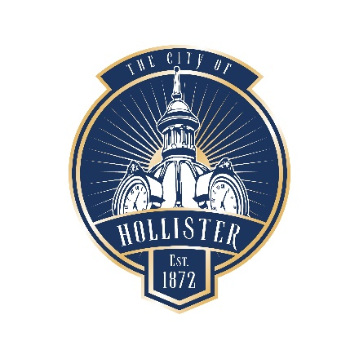

NOTICE OF CANCELLATION

HOLLISTER ART AND CULTURE ADVISORY COMMISSION
375 Fifth Street, Hollister CA 95023
City Hall

Notice is hereby given that the regular meeting of the City of Hollister Art and Culture Commission scheduled for January 14, 2025, has been canceled.

The next regular meeting will be held on Tuesday, February 11, 2025, at 6:00 p.m. in the City Council Chambers at the Hollister City Hall, 375 Fifth Street, Hollister, CA 95023.

This notice for the Art and Culture Commission of the City of Hollister was posted on the bulletin board at City Hall on January 10, 2025, per Government Code Section 54954.2

